BIT 4107 – Mobile Application Development
ENHANCED PROFESSIONAL STUDENT LOGBOOK
Student Name: ____Faith Akinyi__________________________
Admission Number: _____BIT/2024/73801_________________________
School/Faculty: ______Mount Kenya University_________
Programme: _______INFORMATION TECHNOLOGY_______________________
Academic Year: ____2026__________________________
Semester: _________2nd Sem_____________________
Lecturer: ________Mr.Michael Nyoro______________________
Phone Number: _______0769588145_______________________

Instructions
This logbook is used to document weekly learning activities, practical exercises, skills acquired, challenges encountered, solutions applied, and reflections. Students should complete all sections every week.
Each week to follow remarks in week 1 section.

Autogenerated Table of content
Table of Contents
Instructions 2
Week 1: Introduction to Mobile Application Development 4
Practical Activities Undertaken 4
Tools/Software Used 4
Personal Reflection 5
Week 2: Mobile Development Environment 6
Tools/software used: 7
Personal Reflection 7
Week 3: User Interface Design 7
Tools used: 10
Personal Reflection 10
Week 4: Event Handling and User Interaction 10
Tools used: 12
Personal reflection: 12
Week 5: Data Management 12
Personal reflection: 13
Week 6: Networking and APIs 14
Tools used: 14
Personal reflection: 14
Week 7: Application Architecture 16
Same as week 1 16
Week 8: Project Planning 17
Week 9: Device Features and Sensors 18
Same as week 1 18
Week 10: Notifications and Background Services 19
Same as week 1 19
Week 11: Mobile Security 20
Same as week 1 20
Week 12: Testing and Debugging 20
Same as week 1 20
Week 13: Application Deployment 20
Same as week 1 20
Week 14: Final Project Presentation 20
Same as week 1 20
Semester Project Tracking 21
Project Title 21
Project Objectives 21
Project Requirements 21
Development Milestones 21
Testing Results 21
Lessons Learned 21
Future Improvements 21
End of Semester Reflection 22
Summary of Skills Acquired 22
Most Interesting Topic 22
Major Challenges Faced 22
How Challenges Were Overcome 22
Professional Growth Achieved 22
Overall Course Experience 22
Final Approval 22

Week 1: Introduction to Mobile Application Development

Practical Activities Undertaken
I learnt the various apps for mobile development together with installing the tools

Tools/Software Used
Android studio


Personal Reflection
I setup android studio and I learnt the introduction of mobile application development.

Week 2: Mobile Development Environment
SDK Setup in android studio
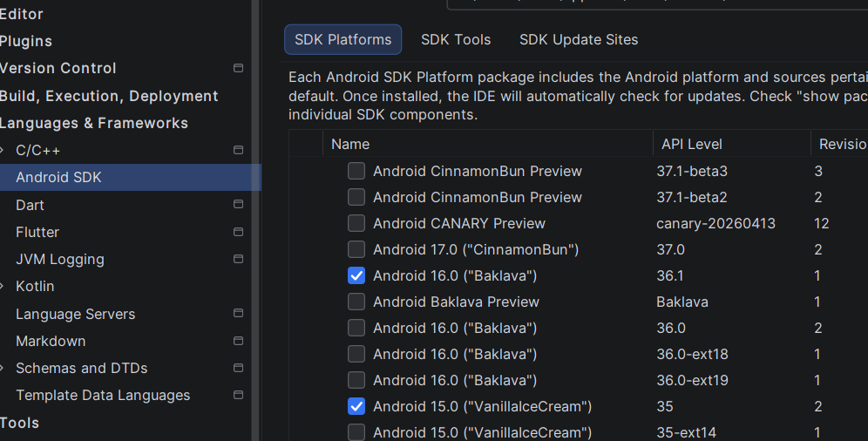
Running emulator
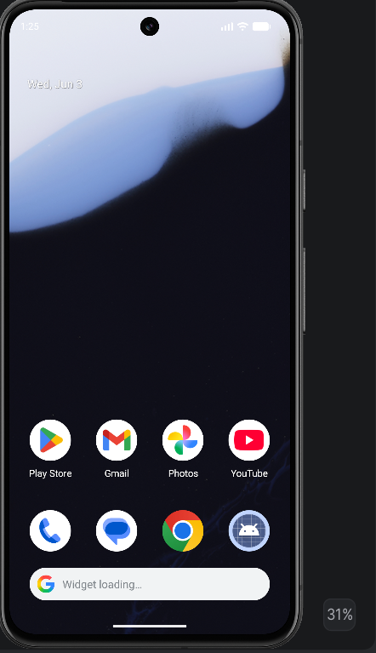

Tools/software used:
Android Studio IDE, Java Development Kit (JDK), Android Virtual Device (AVD) Manager

Personal Reflection
Setting up the sdk for android studio and running the emulator was a good first step. This enabled me to understand how real-life developers prepare tools before building applications.

Week 3: User Interface Design
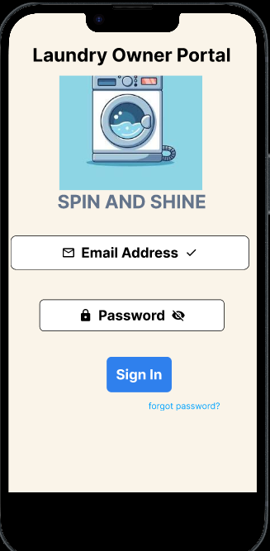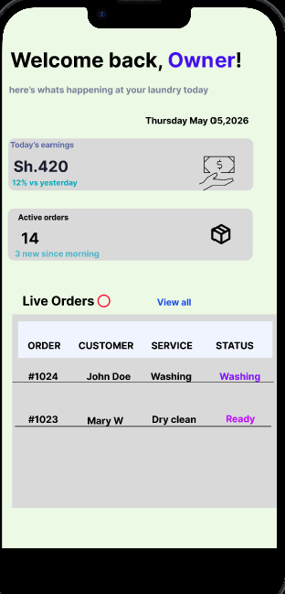

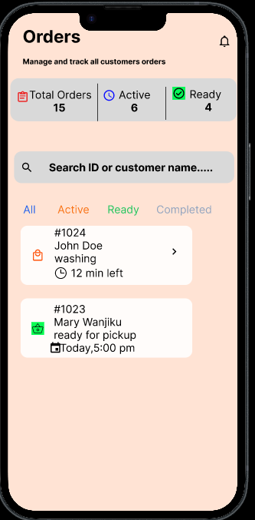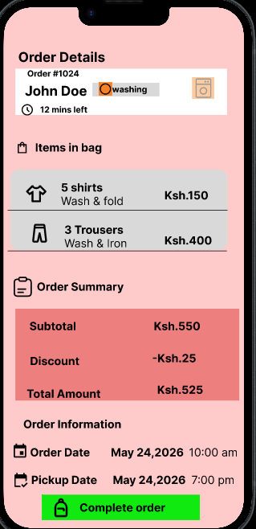

Tools used:
Figma

Personal Reflection
-I learnt how to design my 5 screens of my laundry owner portal using figma and i was able to create a dashboard where the owner can view live orders and a navigation flow that helps the owner to go through the screens.

Week 4: Event Handling and User Interaction

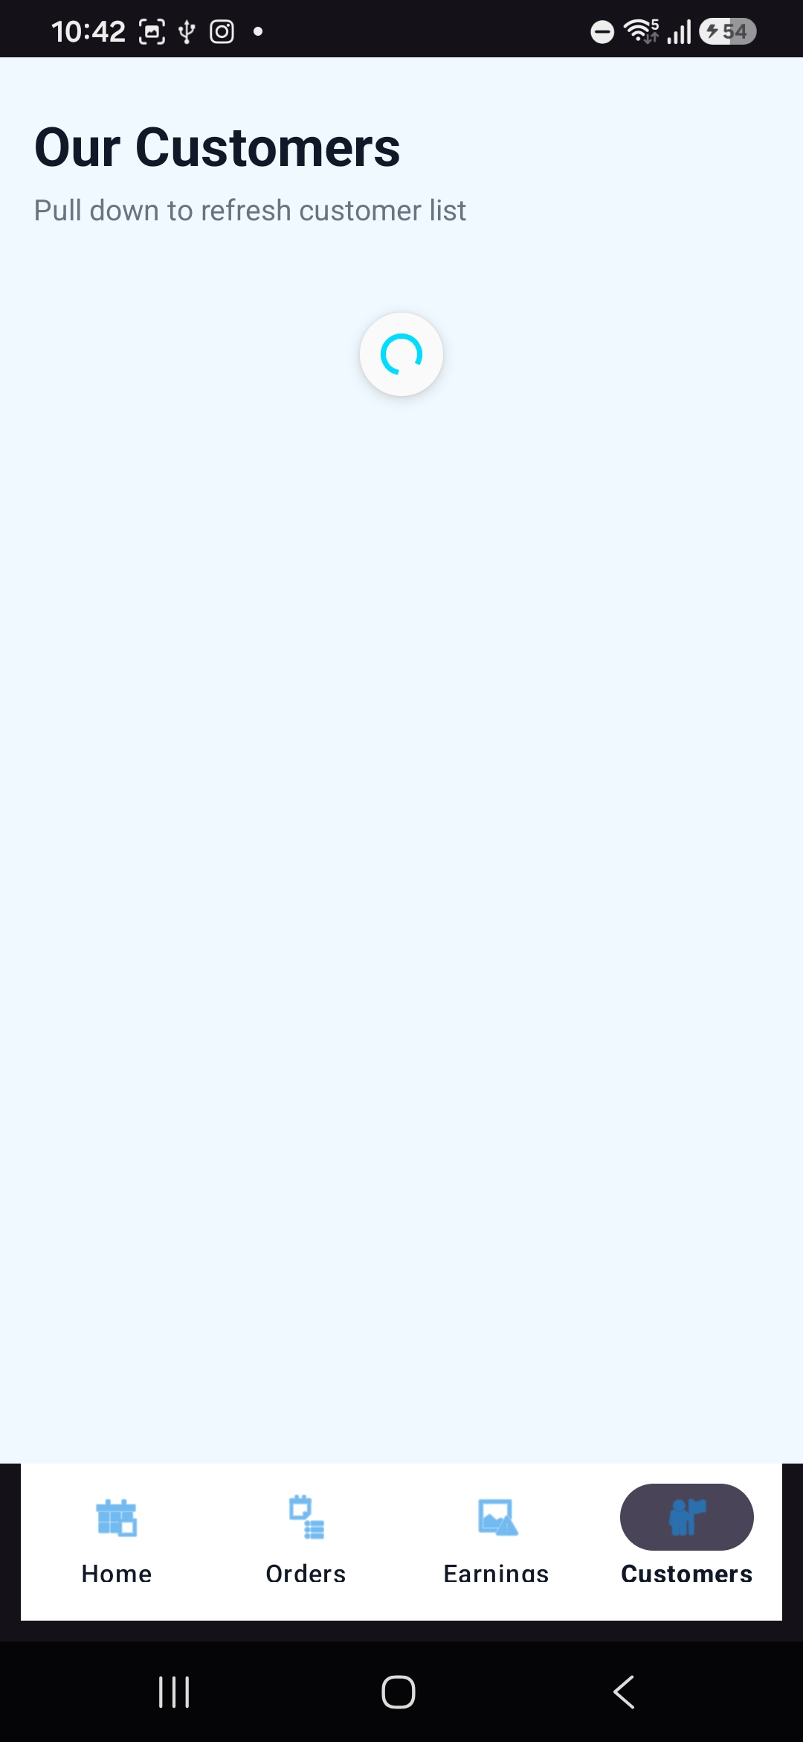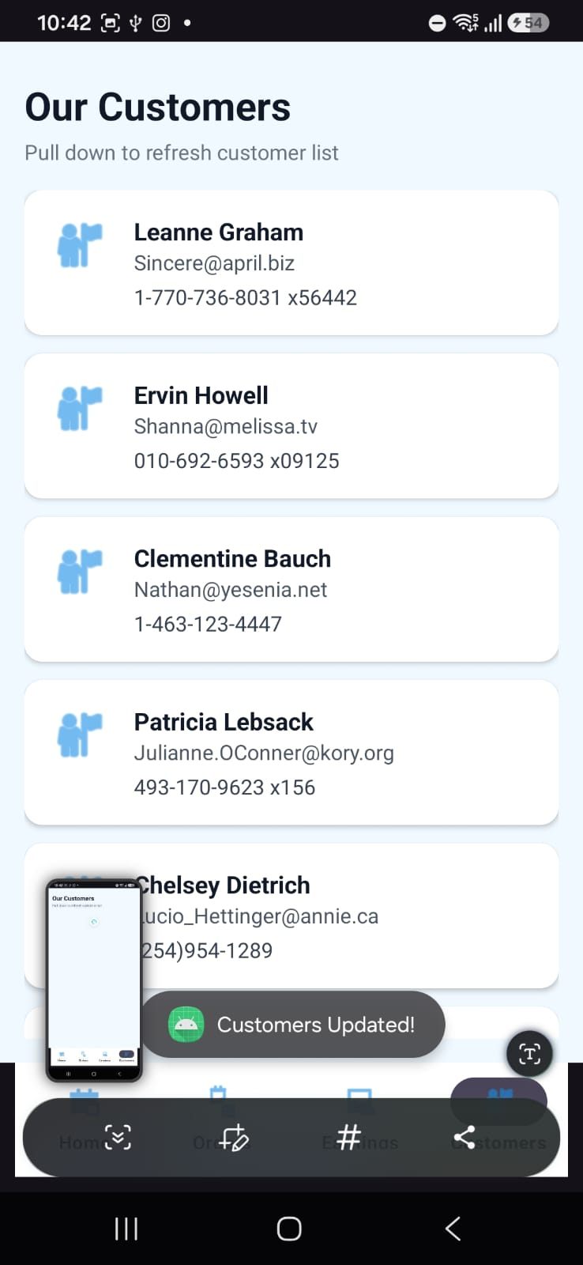

Tools used:
-Android studio
-Java

Personal reflection:
I learnt how to make apps interactive using event handling. I was able to update and load the customers tab which helped me understand how user actions trigger code executions in mobile apps

Week 5: Data Management
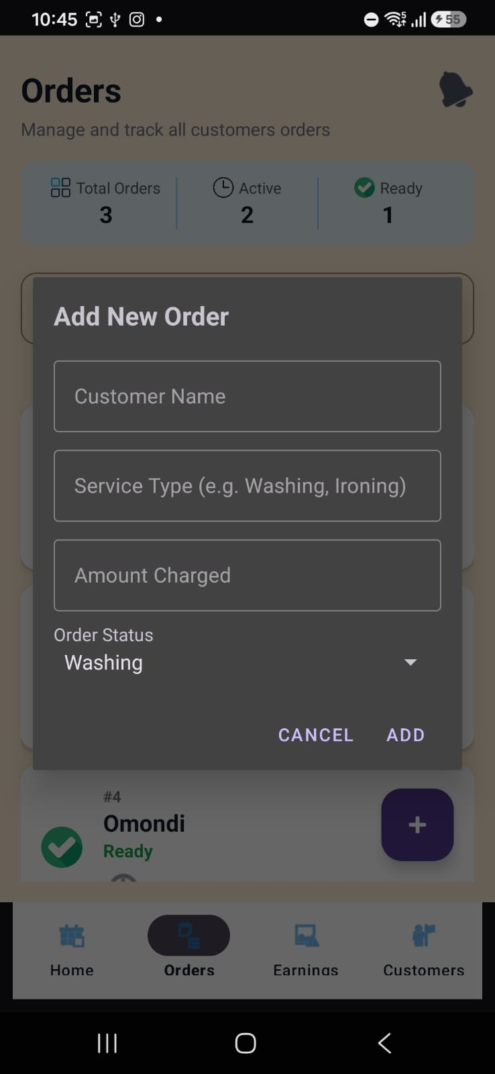

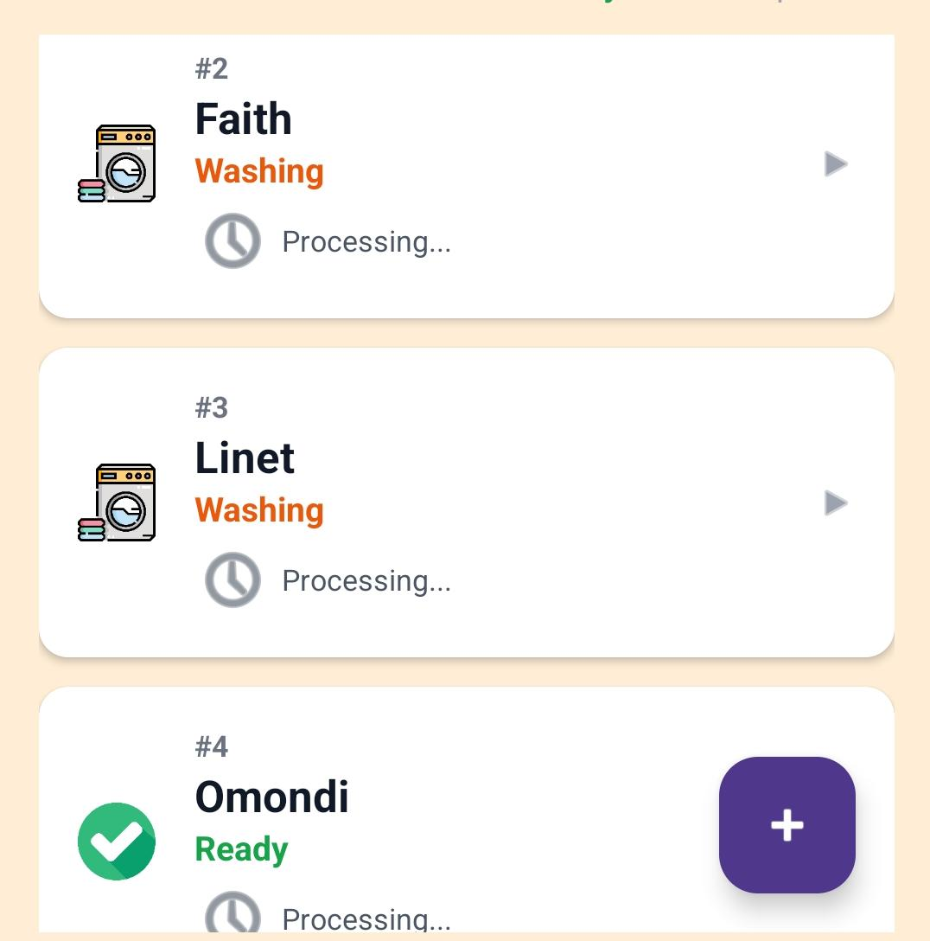
Tools used:
-Android studio
-Java

Personal reflection:
I learnt how to store and retrieve data in android studio. It helped me to understand how apps retain user information even after closing

Week 6: Networking and APIs
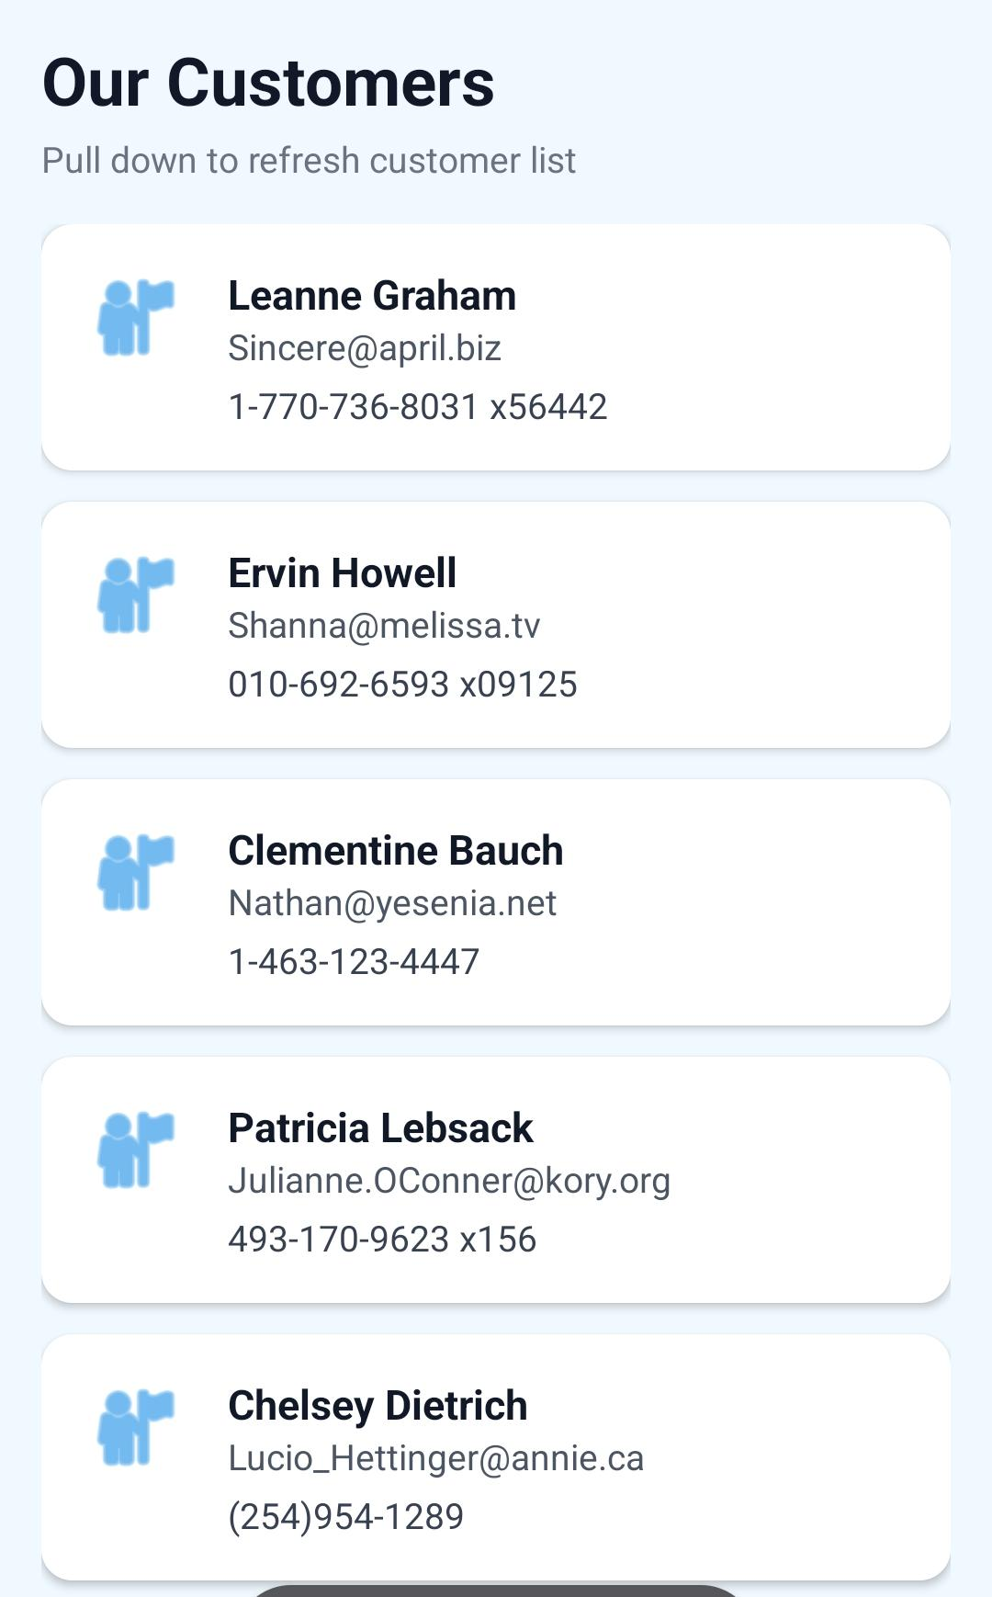
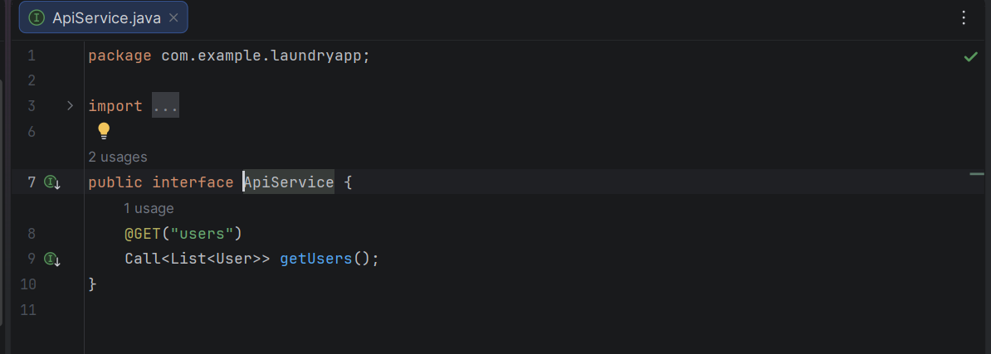

Tools used:
-JSON
-Android studio

Personal reflection:
I learnt how mobile apps communicate external servers using APIs. I understood how data is fetched and displayed dynamically

Week 7: Application Architecture

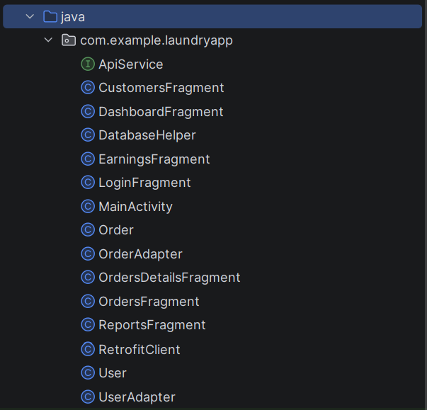
Tools used
-Android studio
-java
Personal reflection
-I learnt the importance of structural organization in mobile development by separating UI components like fragments, network handlers like Retrofit, data models and adapters

Week 8: Project Planning
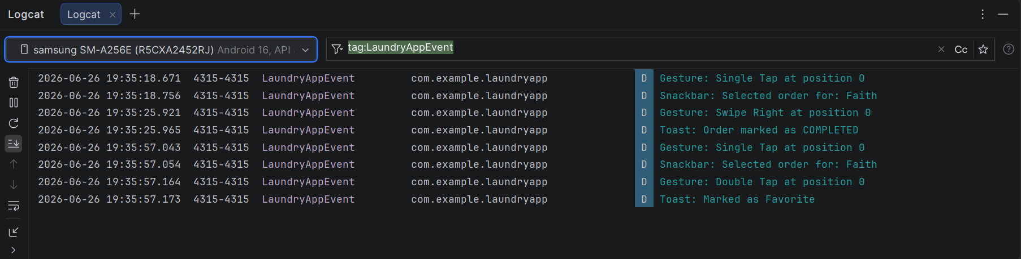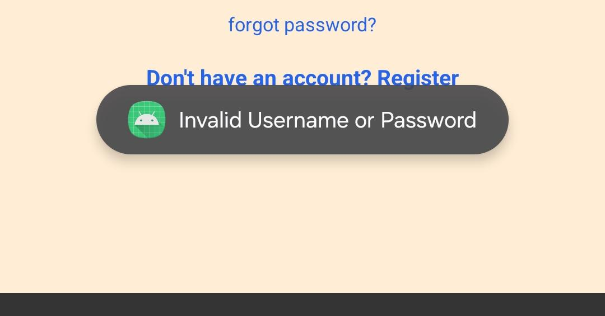

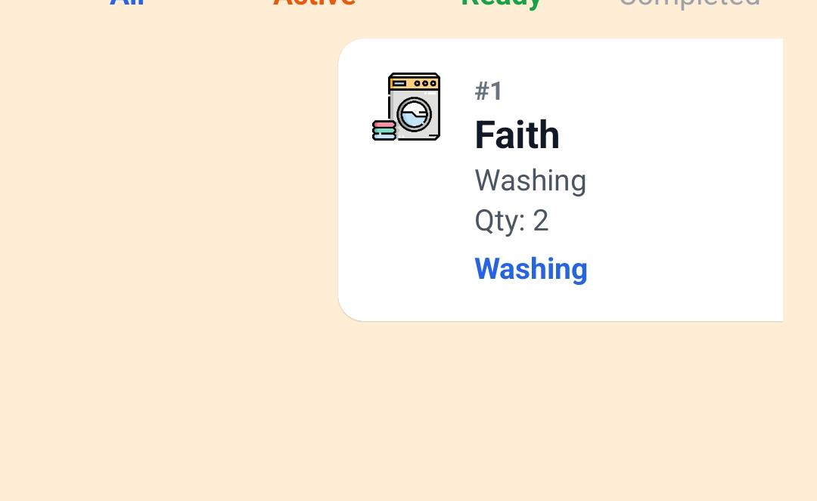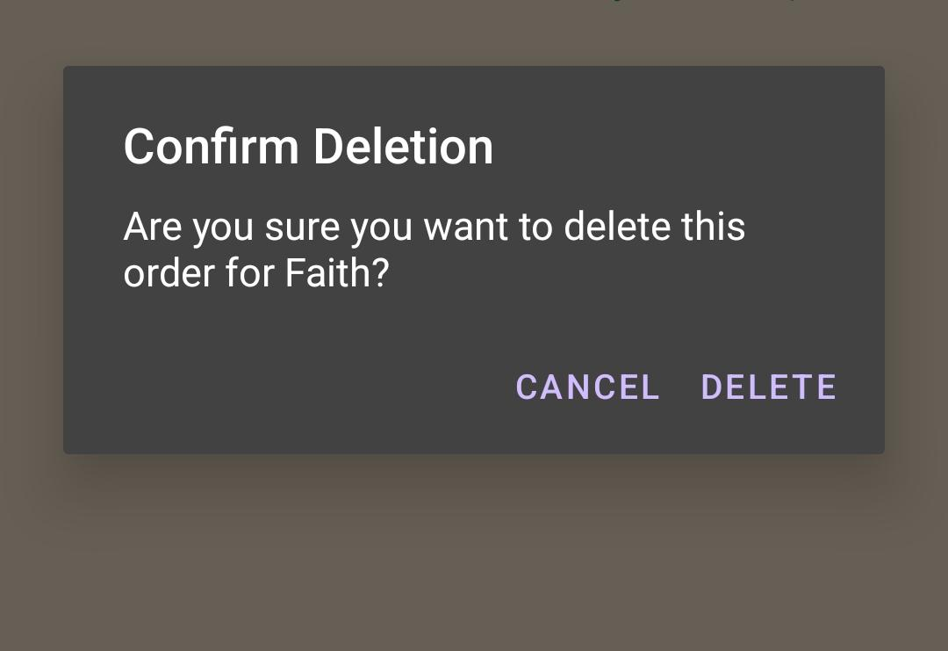

Tools used:
-Android studio
-Java

Personal Reflection
This week’s task improved my understanding of event driven programming. I learnt how to handle keyboard input, touch gestures and input invalidation while organizing code into reusable classes and this made my android app to be more interactive and easier to maintain

Week 9: Device Features and Sensors

Same as week 1

Week 10: Notifications and Background Services

Same as week 1

Week 11: Mobile Security

Same as week 1

Week 12: Testing and Debugging

Same as week 1

Week 13: Application Deployment

Same as week 1

Week 14: Final Project Presentation

Same as week 1

Semester Project Tracking

Project Title

Project Objectives

Project Requirements

Development Milestones

Testing Results

Lessons Learned

Future Improvements

End of Semester Reflection

Summary of Skills Acquired

Most Interesting Topic

Major Challenges Faced

How Challenges Were Overcome

Professional Growth Achieved

Overall Course Experience

Final Approval
Student Name: __________________________
Student Signature: ______________________
Date: _________________________________
Lecturer Name: _________________________
Lecturer Remarks: _____________________
Date: _________________________________

